Report on
National Seminar on “Synthetic Biological Approaches on Environmental Sustainability”
Date: 11/11/2022
Organized by PG and Research Department of Botany

- Invitation
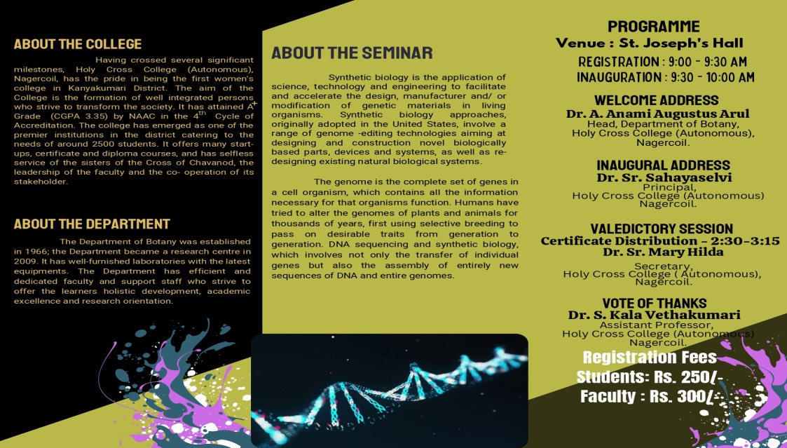

- Photo
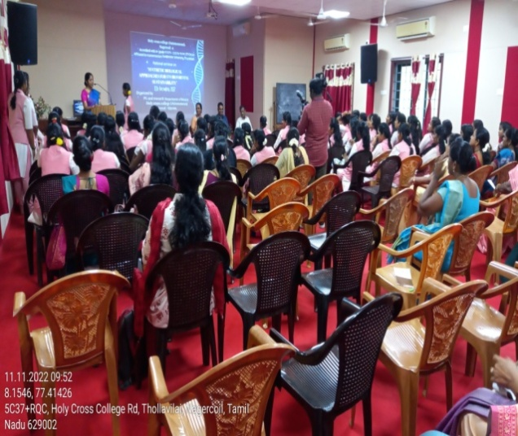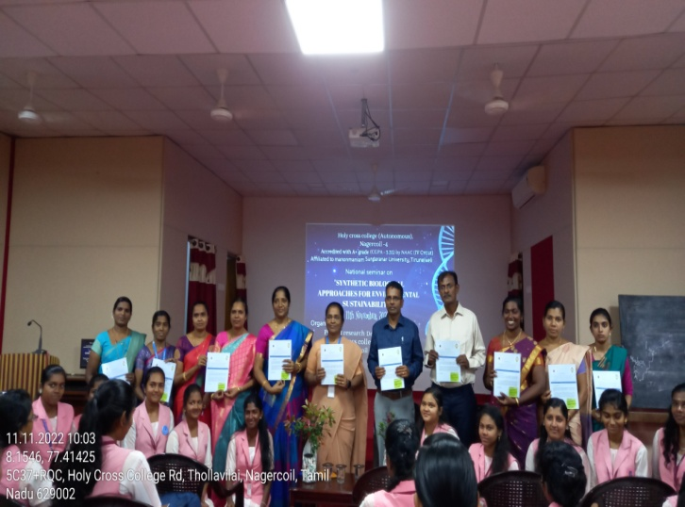

- Report of National Seminar on “Synthetic Biological Approaches on Environmental Sustainability”
Holy Cross College, (Autonomous) Nagercoil, Department of Botany organized an one day National seminar on “Synthetic Biological Approaches on Environmental Sustainability” on November 11th 2022 in St. Josephs hall. The seminar focused on Environment sustainability. The programme started at 9:30 am and the inaugural session began with the prayer song. Dr. A.Anami Augustus Arul, Head of the Department welcomed the gathering. Our Principal Dr. Sr. Sahaya Selvi gave a wonderful Inaugural Address. Followed this our department Newsletter was released by our Principal. Next Dr. Bojaxa A. Rosy introduced the session I cheif guest. The resource person of the National seminar was Dr.Joseph Selvin, Professor& Head, Department of Microbiology, School of Life Sciences, Pondicherry University. He explained the synthetical Biological Approaches. The afternoon session started at 1.15 pm, Dr. J. Celin Pappa Rani introduced the cheif guest Dr. J. Rajesh Banu, Associate Professor, Department of Biotechnology, Central University of Tamilnadu, The resource person explained briefly about plant biomass production. Dr. S. Kala Vetha Kumari proposed a vote of thanks. 105 students 10 faculty member, 14 Scholars from various colleges both inside and outside were actively participated. The seminar came to an end with the National Anthem. Feedbacks were collected from the participants via google sheet with the positive comments. The programme wrapped up around 3:15 pm.
- Attendance

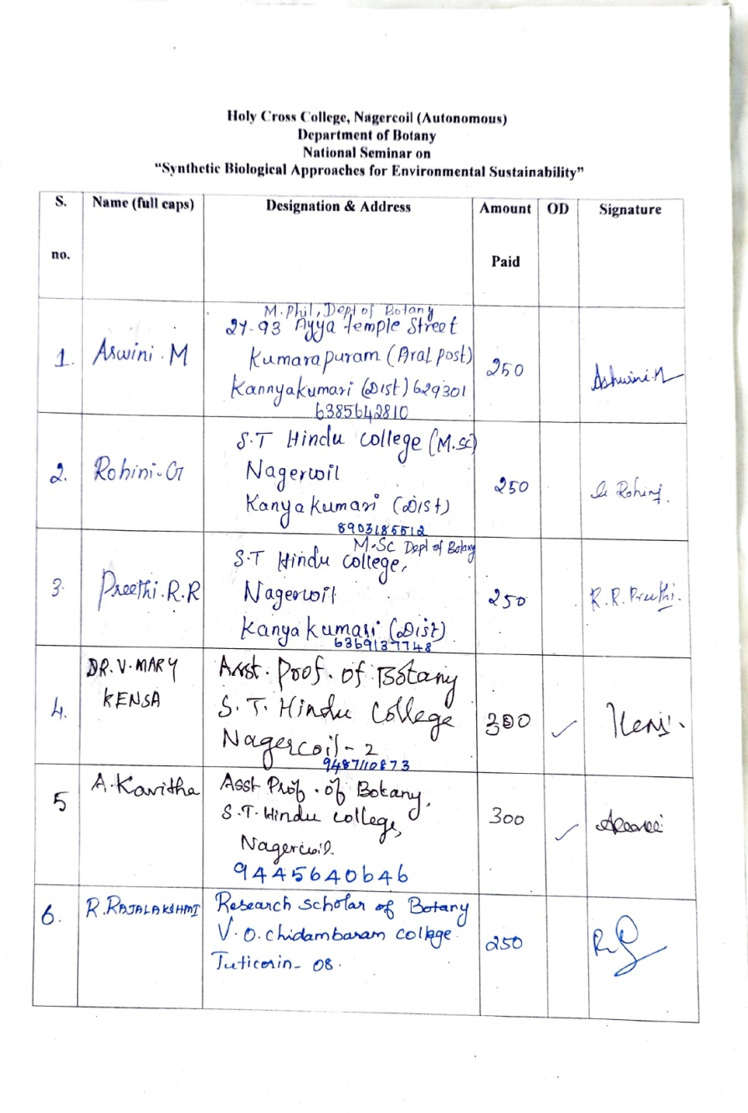

5. Certificate

